**IBM IoT Assignment – 1**

1. **Make a Smart Home in Tinkercad, using 2+ sensors, Led, Buzzer in single code and circuit.**

* The sensors **connected** to the microcontroller board are Smoke Detector, Ultrasonic and servo motor.

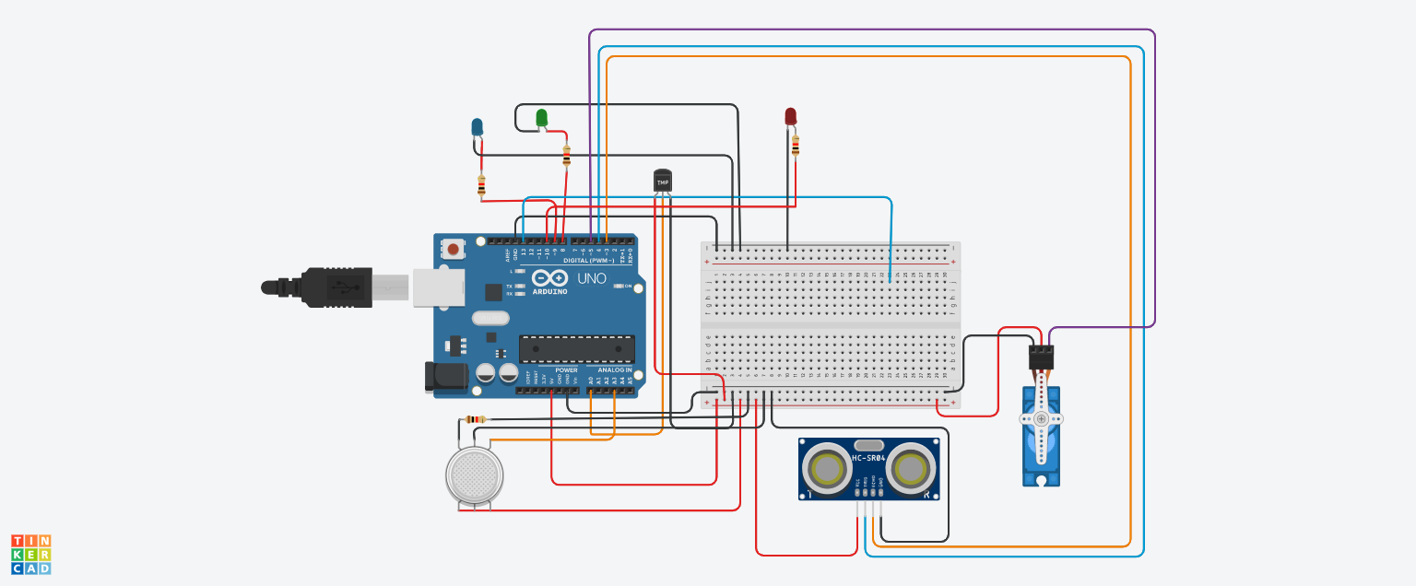

// C++ code //

void setup()

{

Serial.begin(9600);

pinMode(3,INPUT);//Echo from ultrasonic sensor

pinMode(4,OUTPUT); //Trigger for ultrasonic sensor

pinMode(5,OUTPUT); //Output to servo motor

pinMode(8,OUTPUT);//Green LED to indicate decrease in temperature

pinMode(9,OUTPUT);//Blue LED to indicate increase in temperature

pinMode(10,OUTPUT);//Red LED to indicate gas leakage

}

void loop()

{

// Getting the data from the Temperature sensor

double a = analogRead(A0);

// Converting Analog value to Digital Value

double Conv = (((a/1024)*5)-0.5)*100;

Serial.println("The Temperature is :");

Serial.println(Conv);

Serial.println("****************************");

delay(1000);

if(Conv>30)

{

digitalWrite(9,HIGH);

digitalWrite(8,LOW);

}

else

{

digitalWrite(8,HIGH);

digitalWrite(9,LOW);

}

//Ultrasonic sensor

digitalWrite(4,HIGH);

digitalWrite(5,LOW);

delayMicroseconds(10);

digitalWrite(4,LOW);

int time=pulseIn(3,HIGH);

int distance=(time*0.034)/2;

Serial.println("Distance is:");

Serial.println(distance);

if(distance<=20)

{

Serial.println("Person detected");

digitalWrite(5,HIGH);

delay(500);

}

else

{

digitalWrite(5,LOW);

delay(500);

}

//Gas sensor

int gas = analogRead(A3);

Serial.println("The value of gas leakage is:");

Serial.println(gas);

int thres = 150;

if(gas > thres)

{

digitalWrite(10,HIGH);

}

}

* It's a home automation system where-

1. The door will open if anyone comes near at the door within 40cm and door will be open for 2 seconds. Then it will check again if anyone is still within 40cm, if yes, then the door will still open for 2 more seconds and if no, then the door will automatically be closed. (I used here Ultrasonic Sensor for measuring distance and Servo motor for opening the door).
2. If the room detects any movement, the light (LED) will automatically be lighting. If there is no movement in the room, then the light will remain off. (I used here PIR for detecting movement and LED for Light).
3. It will detect room temperature and if that is greater than 20 (degree Celsius) then a fan will be running, otherwise, the fan will remain stopped. (I used here temperature sensor LM35 for detecting temperature and a motor for running a fan).

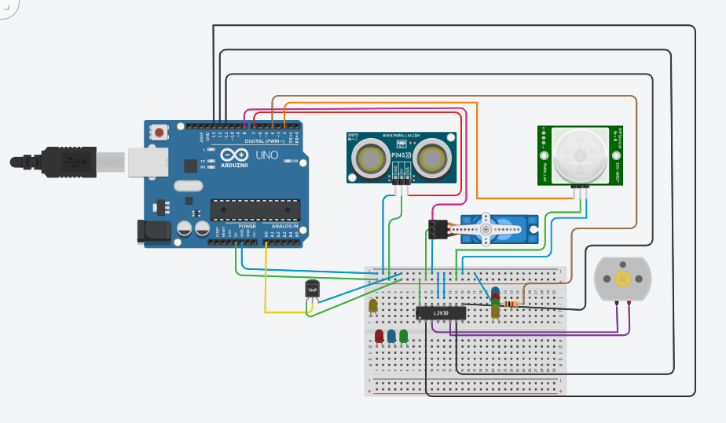

#include<Servo.h>

const int pingPin = 7;

int servoPin = 8;

Servo servo1;

void setup() {

// initialize serial communication:

Serial.begin(9600);

servo1.attach(servoPin);

pinMode(2,INPUT);

pinMode(4,OUTPUT);

pinMode(11,OUTPUT);

pinMode(12,OUTPUT);

pinMode(13,OUTPUT);

pinMode(A0,INPUT);

digitalWrite(2,LOW);

digitalWrite(11,HIGH);

}

void loop() {

long duration, inches, cm;

pinMode(pingPin, OUTPUT);

digitalWrite(pingPin, LOW);

delayMicroseconds(2);

digitalWrite(pingPin, HIGH);

delayMicroseconds(5);

digitalWrite(pingPin, LOW);

// The same pin is used to read the signal from the PING))): a HIGH pulse

// whose duration is the time (in microseconds) from the sending of the ping

// to the reception of its echo off of an object.

pinMode(pingPin, INPUT);

duration = pulseIn(pingPin, HIGH);

// convert the time into a distance

inches = microsecondsToInches(duration);

cm = microsecondsToCentimeters(duration);

//Serial.print(inches);

//Serial.print("in, ");

//Serial.print(cm);

//Serial.print("cm");

//Serial.println();

//delay(100);

servo1.write(0);

if(cm < 40)

{

servo1.write(90);

delay(2000);

}

else

{

servo1.write(0);

}

// PIR with LED starts

int pir = digitalRead(2);

if(pir == HIGH)

{

digitalWrite(4,HIGH);

delay(1000);

}

else if(pir == LOW)

{

digitalWrite(4,LOW);

}

//temp with fan

float value=analogRead(A0);

float temperature=value*0.48;

Serial.println("temperature");

Serial.println(temperature);

if(temperature > 20)

{

digitalWrite(12,HIGH);

digitalWrite(13,LOW);

}

else

{

digitalWrite(12,LOW);

digitalWrite(13,LOW);

}

}

long microsecondsToInches(long microseconds) {

return microseconds / 74 / 2;

}

long microsecondsToCentimeters(long microseconds) {

return microseconds / 29 / 2;

}